SETTING UP ANGULAR IN VISUAL STUDIO 2017

Is it possible to run Angular and Type Script in Visual Studio? Yes it is. Here I document how I set this up.

This is the version of VS 2017 that I am using and I code using C#:

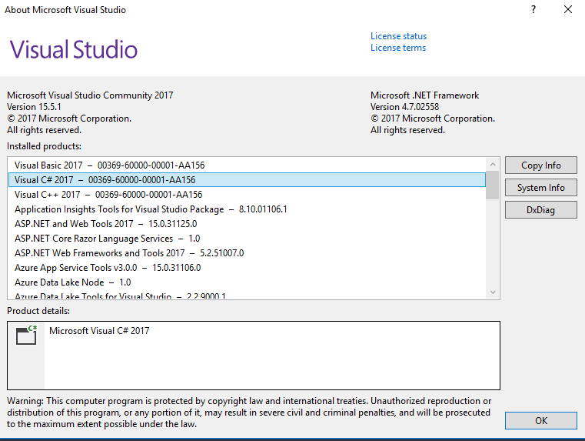

**DOWNLOADING NODE.JS AND NPM FROM THE NODEJS WEBSITE**

Firstly we need to install NODE.js and npm, node package manager. These need to be downloaded and installed on your machine.

VS requires Node version 4.6x or greater

NPM 3.x.x or greater

These are downloaded together in a single package which can be found at:

<https://nodejs.org/en/download/>

Select the package for your system as for example Windows, macOS etc and down load.

I used Windows Installer 64-bit for my Windows 10 machine.

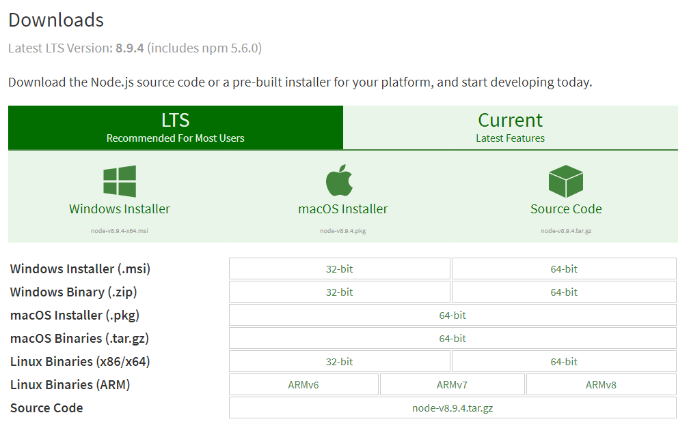

**For Windows users how do you determine which operating system you have?**

Go to the search window and type **msinfo32.**

This will bring up the system information window and look up System Type. If it says x64-based PC then you have a 64 bit processor. If it says x86-based PC then you have a 32 bit operating system.

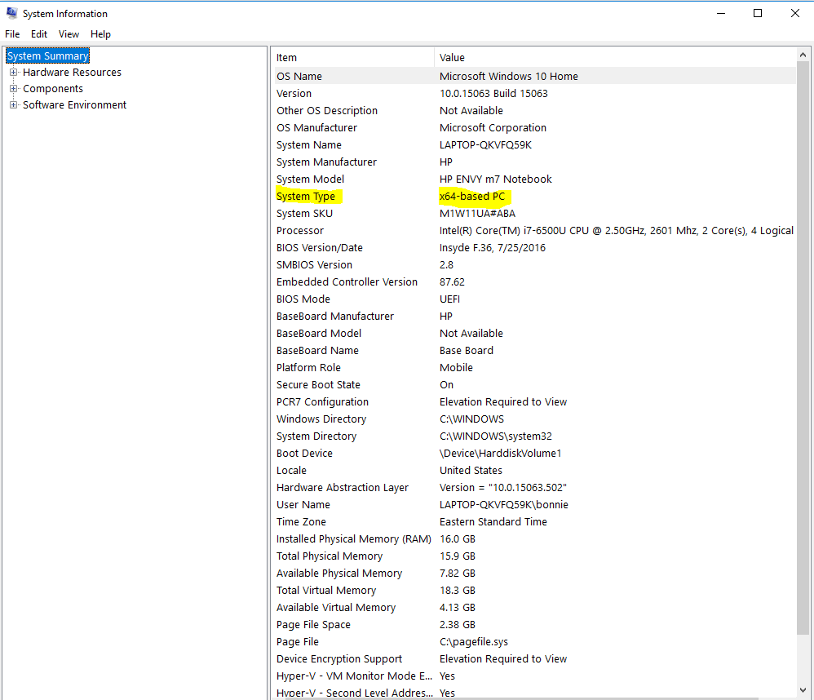

Select the appropriate download package.

This will download an msi file into your downloads folder.



Right click on the msi and select INSTALL and follow the instructions.

**AFTER DOWNLOADING YOUR NODE PACKAGE:**

After installation of node and npm, type cmd in the search box and bring up the command window.

To see which version of node you have installed type: node -v

To see which version of npm you have installed type: npm -v

**CONFIGURING VISUAL STUDIO TO RUN NODE**

Open an instance of Visual Studio and go to Tools 🡪 Options 🡪 Projects and Solutions🡪 Web Package Management 🡪 External Web Tools. You will see:

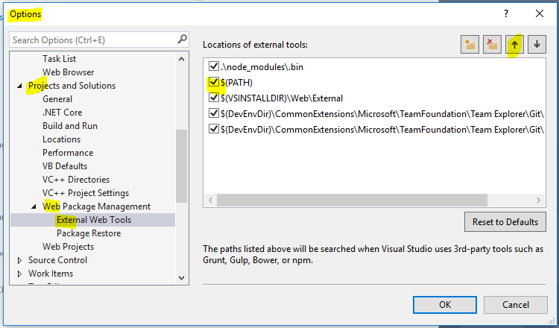

Move the global path entry, $(PATH), up to second position in the queue by selecting it and using the up arrow so that it looks like the configuration above. This tells Visual Studio to look for npm in the global path before it searches other folders.

**DOWNLOADING AND INSTALLING TYPESCRIPT**

The next package that needs to be downloaded and installed is TypeScript.

This can be obtained from <https://www.microsoft.com/en-us/download/>

Do a search on typescript

<https://www.microsoft.com/en-us/search/result.aspx?q=typescript+dev+download>

For my system I selected TS for VS2017

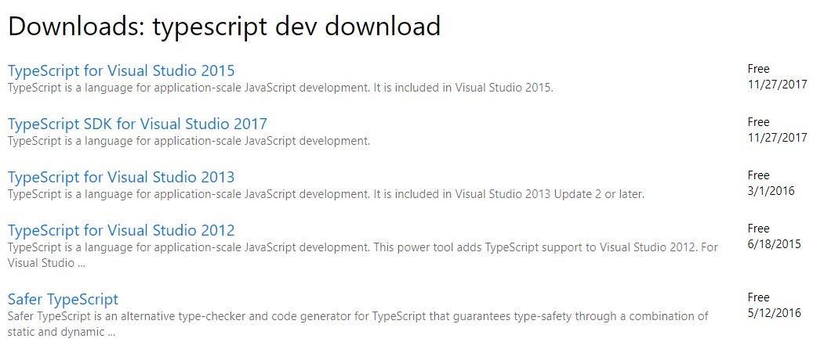

Download the TypeScript executable to your downloads folder.



Right click the executable and install as administrator. Follow the instructions for the install.

For Angular applications the version of TypeScript must be 2.2.0 or later.

How can I verify what was installed?

After installing go to Visual Studio and click Help 🡪About Microsoft Visual Studio🡪 TypeScript Tools

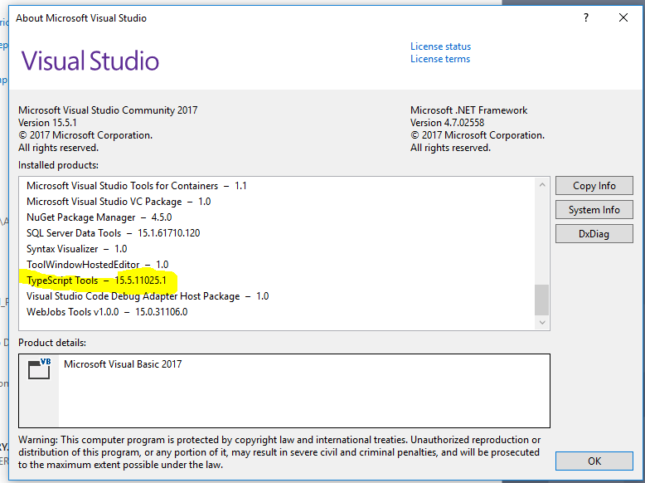

You have now installed the software that will be needed for an Angular application.

**CREATING AN ANGULAR APPLICATON – setting up the application in Visual Studio 2017**